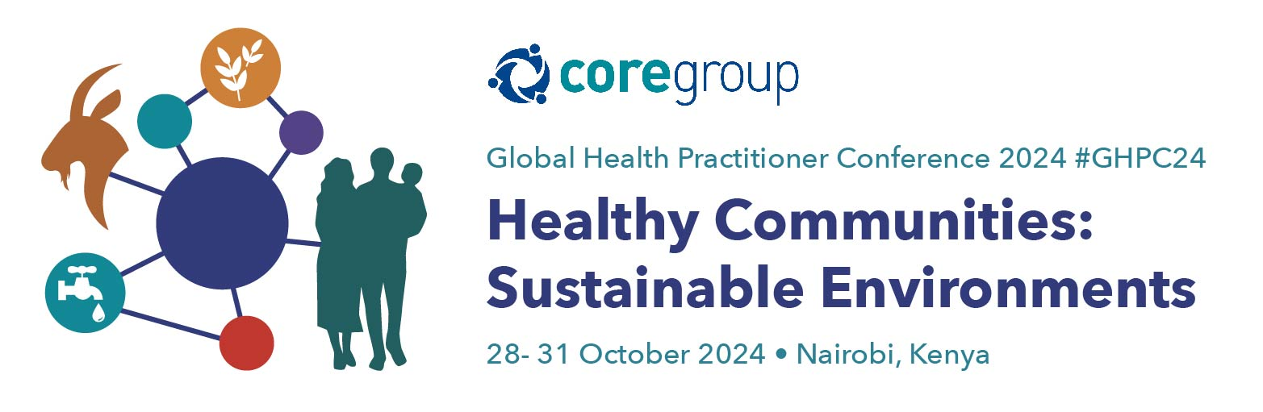

COMMUNITIES | CLIMATE | COLLABORATION
For Community Health

CORE Group GHPC24 Social Media Messages

We encourage you to share #GHPC24 with your networks, so together we can drive more dynamic learning and networking at the conference. Please feel free to use the following outreach announcements and our conference logo to spread the word.
Don’t forget to follow CORE Group on Twitter and LinkedIn to receive the latest conference updates.
Twitter: @COREGroupDC Facebook: CORE Group LinkedIn: CORE Group

Key Dates:
- Monday, October 28, 2024:
The conference kicks off with Skills-Building Sessions from 9:00 AM – 1:00 PM, followed by Lunch and Expo Tables from 1:00 PM – 2:00 PM. The day will conclude with Site Visits from 2:00 PM – 5:00 PM.

- Tuesday, October 29, 2024:
The official opening will feature a keynote address and networking opportunities. Concurrent sessions will take place from 11:00 AM – 12:30 PM, followed by Lunch and Expo Tables from 12:30 PM – 2:00 PM. Technical Roundtables will be held from 2:00 PM – 3:30 PM, with additional Concurrent Sessions from 4:00 PM – 5:30 PM. The day will close with the Awards Ceremony and Happy Hour from 5:30 PM – 7:00 PM.
- Wednesday, October 30, 2024:
The day begins with a Plenary Session from 9:00 AM – 10:00 AM, followed by the Pitch Challenge from 10:30 AM – 12:30 PM. Lunch and Expo Tables will be available from 12:30 PM – 2:00 PM. Concurrent Sessions on Climate Change and Health will take place from 2:00 PM – 3:30 PM, followed by a closing Plenary Session from 3:30 PM – 5:00 PM.
- Thursday, October 31, 2024:
The final day will focus on collaboration, technical roundtables, and closing plenary sessions. The day begins with an opening plenary from 9:00 AM – 10:00 AM, followed by a break and Expo Tables from 10:00 AM – 10:30 AM. Concurrent Sessions on collaboration will run from 11:00 AM – 12:30 PM. Lunch and Expo Tables will be held from 12:30 PM – 2:00 PM, followed by Technical Roundtables from 2:00 PM – 3:15 PM. The day and conference will close with a final Plenary Session from 3:30 PM – 4:45 PM.

Key Hashtags:
- Primary Hashtag: #GHPC24
- Other Hashtags: #CommunityHealth #GlobalHealth #SBC #HealthForAll #OneHealth #GHPCYouth #CORE Group #Climate #Communities #Collaboration #SocialandBehaviourChange #MaternalChildHealth #Healthequity

(Participants)

Pre-Conference Excitement:
- "Excited to be attending CORE Group #GHPC24! Looking forward to plenary sessions on [insert session name] #CommunityHealth and learning from inspiring global leaders. Let’s drive together! Make sure to register today at: https://conference.coregroup.org/registration/

- "Looking forward to attending the 2024 CORE Group Global Health Practitioners Conference (#GHPC24) in 3 weeks! This is an exciting opportunity to engage with global health experts and drive change in community health. Who else is attending?" Make sure to register today at: https://conference.coregroup.org/registration/”

- "Excited to be part of the CORE Group #GHPC24 community this year. The lineup of sessions, speakers, and sponsors is inspiring! Looking forward to expanding my knowledge on [specific topic] and collaborating with peers to find solutions." Make sure to register today at: https://conference.coregroup.org/registration/”

- Let’s inspire leaders to take action on global health solutions! Just a few weeks to go—be sure to register today and join us on this impactful journey. See you there! Register now at: https://conference.coregroup.org/registration/ ”

During the Conference:

- "Inspired by the incredible insights shared today at CORE Group #GHPC24’s plenary on [insert session topic]! Let’s take these ideas forward to build healthier communities. #CommunityHealth"

- "Attending the [insert session name] at CORE Group #GHPC24 today. I am excited to dive deep into strategies for improving community-driven health initiatives! Great insights from [speaker’s name] and CORE Group members."

- "Today’s session at CORE Group #GHPC24 on [insert topic] was incredibly thought-provoking. The discussions around [key insight] will surely influence how we approach our projects moving forward. Thank you to the speakers for their expertise and to CORE Group for organizing such a meaningful event."

- "Participating in the interactive workshop on [insert topic] at CORE Group #GHPC24 has been a highlight of the conference. The collaborative discussions and practical takeaways are exactly what we need to drive progress in global health initiatives."

Post-Conference Reflections:
- "Feeling energized after attending CORE Group #GHPC24! The sessions on [insert session name] were incredibly powerful. Ready to act and collaborate across sectors! #HealthForAll #OneHealth"

- "What an amazing experience at CORE Group #GHPC24! The discussions around [insert key topic] were insightful and motivating. Looking forward to applying these learnings in my work and continuing the conversations with fellow attendees."

- "Just returned from CORE Group #GHPC24, and it was a truly inspiring experience! The exchange of ideas and strategies, especially around [insert key topic], has equipped me with valuable insights for advancing our global health goals. A big thank you to all the organizers and speakers!"’

- "Wrapping up CORE Group #GHPC24 with a sense of accomplishment and excitement. The sessions and networking opportunities provided great value, and I’m eager to implement the innovative ideas we discussed. Looking forward to continuing the conversations and collaboration!"

Key Message Guidelines:
- When to Post: Post in real-time during the sessions or schedule content around key moments in the conference.
- What to Include: Be sure to tag @COREGroupDC and use hashtags like #GHPC24 in your posts. This helps make your content visible to the entire GHPC community!
- Engage with Fellow Participants: Like, retweet, and share others’ content to maximize the reach of GHPC24’s key discussions and takeaways.

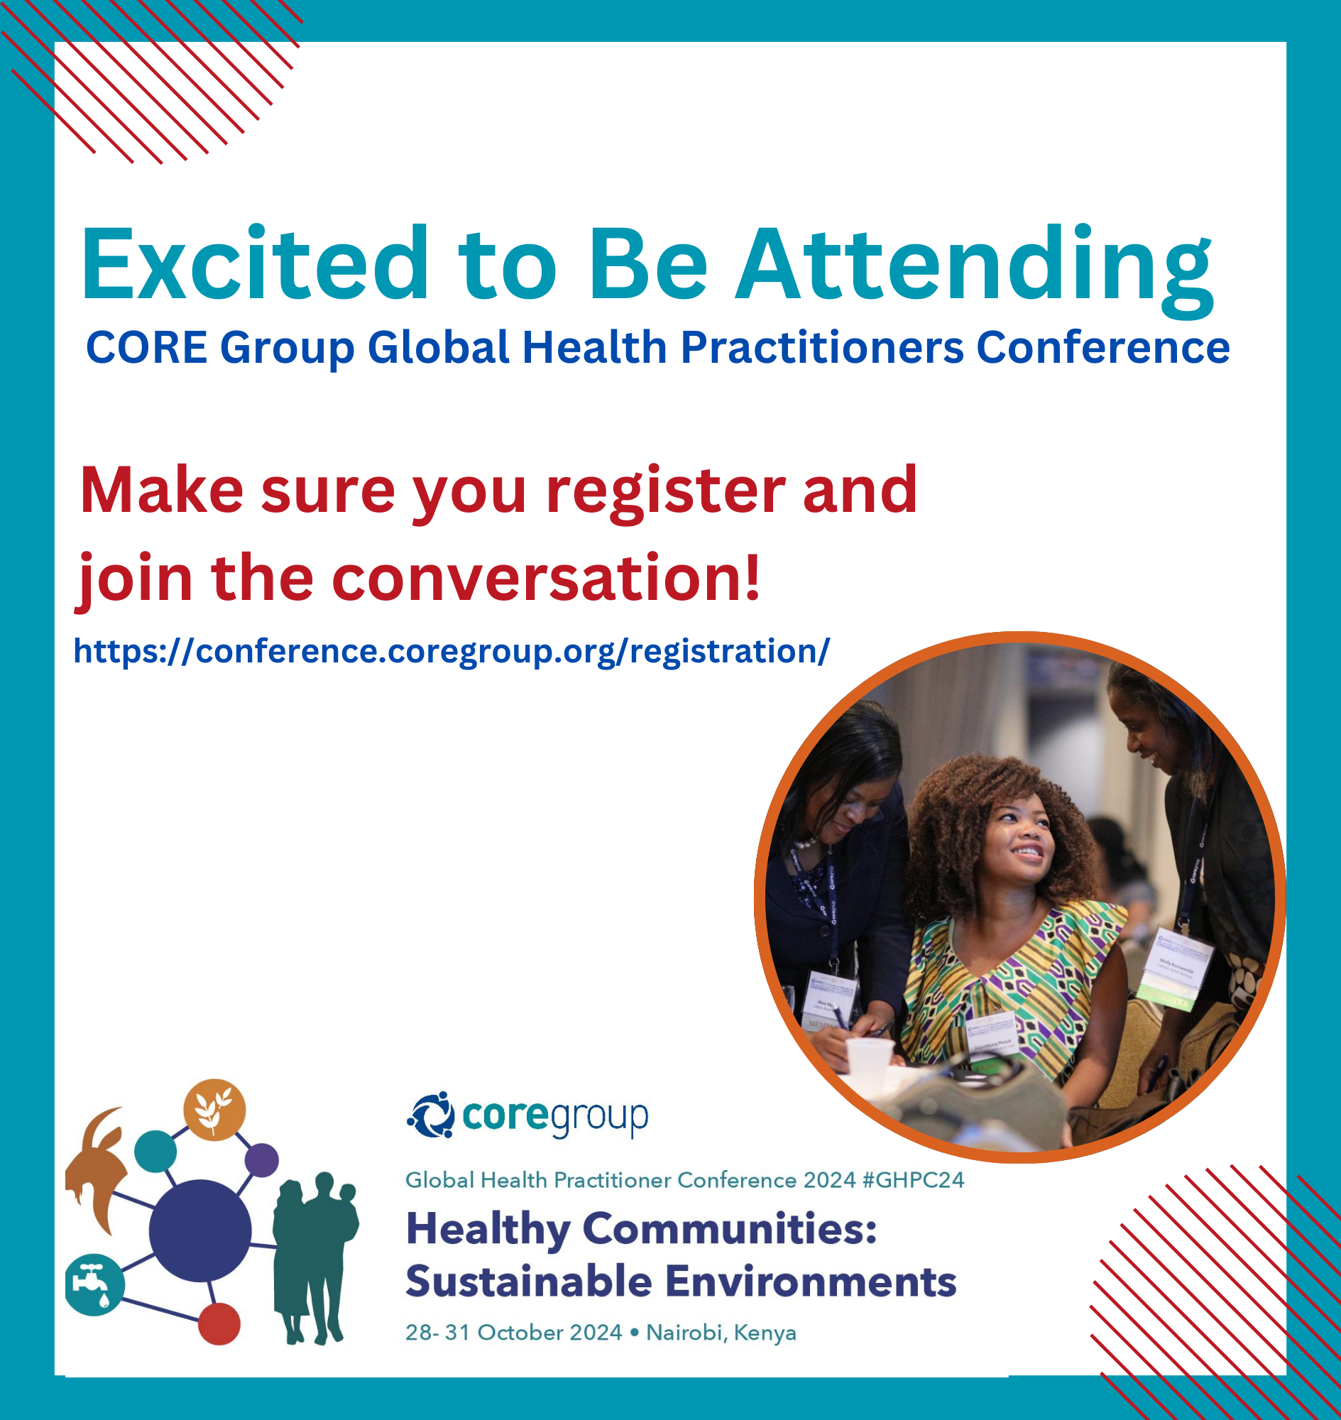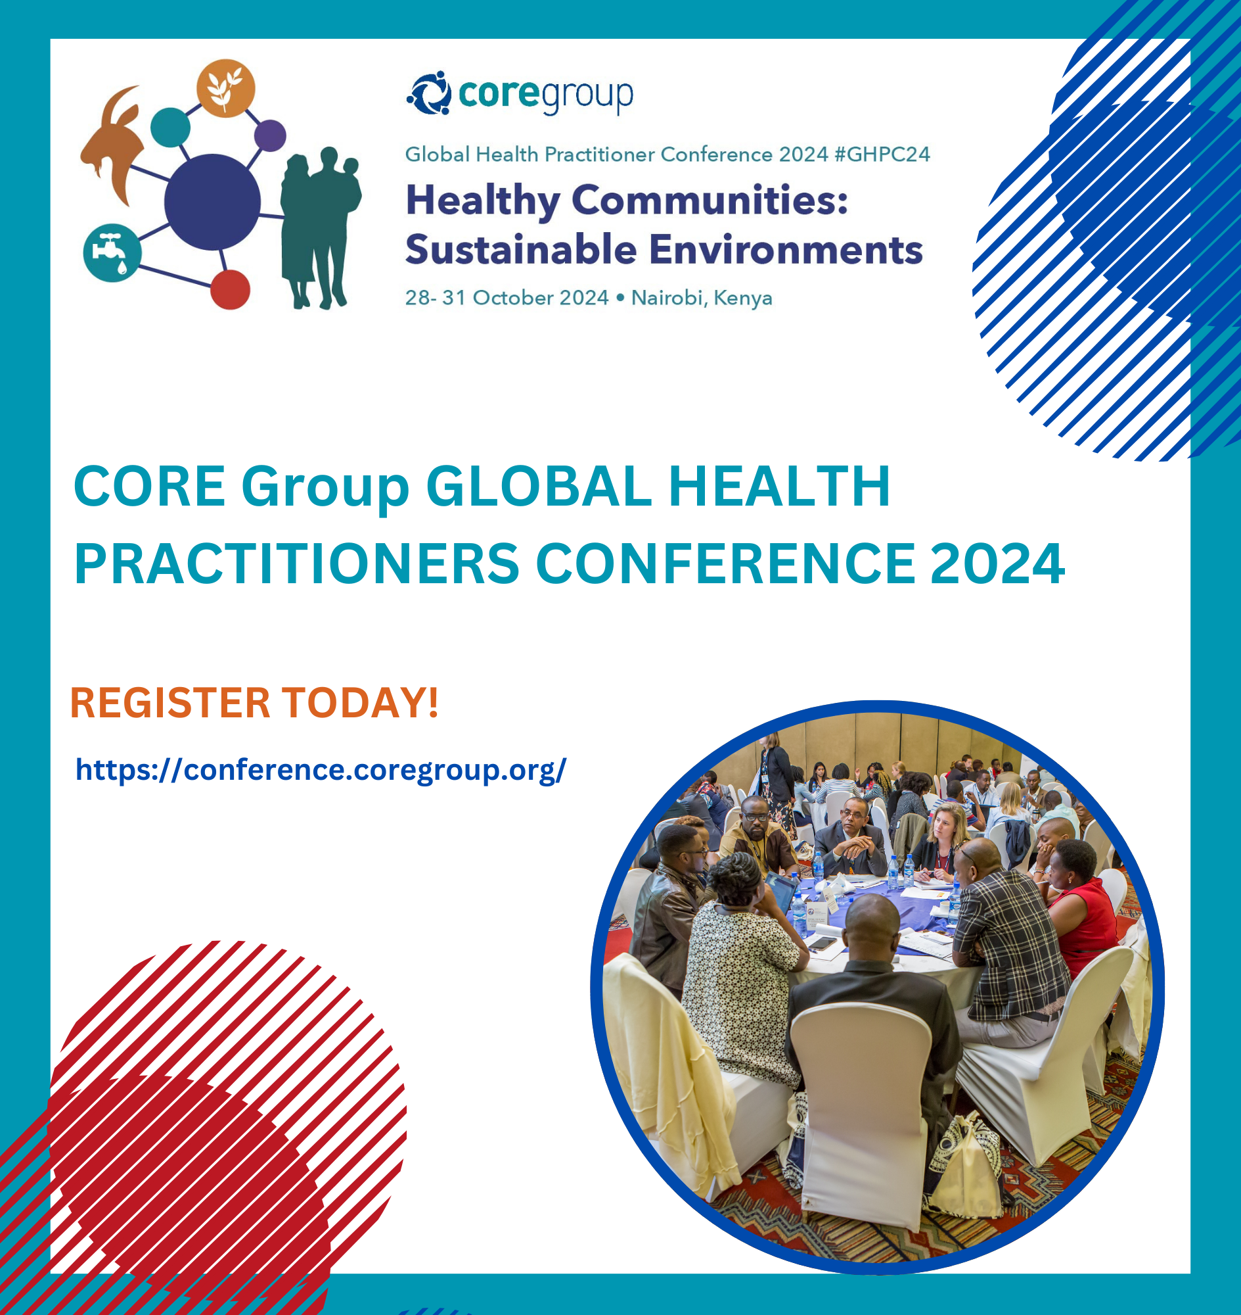

Download social media assets here: GHPC24 Social Media Assets
Let’s amplify the conversation and make the 2024 CORE Group Global Health Practitioners Conference an unforgettable experience!

